
UNIVERSITY COLLEGE DUBLIN
An Coláiste Ollscoile Baile Átha Cliath

UCD SCHOOL OF NURSING, MIDWIFERY & HEALTH SYSTEMS
Scoil na hAltrachta, an Cnáimhseachais agus na gCoras Slainte


In partnership with St John of God University Hospital and HSE Dublin South and Wicklow


Medication Workbook Year 1 BSc Mental Health Nursing Students
Student Name:
Student Number:

1
NCAD© UCD CASC 2025

Introduction

This booklet has been developed as a tool to assist you in gaining knowledge of some commonly used medications in your practice placements in Stage 1 (Year 1). In trimester 1 of Year 1 you will receive an introductory lecture to medication management and professional practice. This workbook will enable you to link theory to practice in relation to medication management. Medication management is an important aspect of your National Competency Assessment Document (NCAD) assessment and the Domains and Performance Indicators specific to this area are detailed in the table below:

Domain 1 | Domain 2 | Domain 3 | Domain 4 | Domain 5 | Domain 6
1.1 | 2.1 | 3.1[c]* | 4.1 | 5.1 | 6.1
1.3 | 2.2 | 3.2 | 4.2 | 5.2 | 6.2
 | 2.3 [f]*
 | 2.4
Table 1: Domains and Performance Indicators that pertain to Medication Management Mental Health General Nursing Practice Placement
*
2.3 [f] Assists the Registered Nurse in the safe administration and management of medicines, in line with local policy

SIGNATURE BANK
Each registered nurse who acts as a preceptor/co-preceptor for this student must sign this bank.

Preceptors/Co-preceptor Name (Print) | Signature | Preceptors/Co-preceptor Initials | Ward/Area

SIGNATURE BANK
Each registered nurse who acts as a preceptor/co-preceptor for this student must sign this bank.

Preceptors/Co-preceptor Name (Print) | Signature | Preceptors/Co-preceptor Initials | Ward/Area

SIGNATURE BANK
Each registered nurse who acts as a preceptor/co-preceptor for this student must sign this bank.

Preceptors/Co-preceptor Name (Print) | Signature | Preceptors/Co-preceptor Initials | Ward/Area

Learning Outcomes

During your Stage 1 placements you should be able to:
- Summarise the Nursing and Midwifery Board of Ireland regulations in relation to medication management. Guidance for Registered Nurses and Midwives on Medication Administration 2020
Nursing and Midwifery Board of Ireland (NMBI), 2020
- Identify and explain the 10 ‘Rights’ (R’s) as per NMBI Guidance
- Describe the use of local policies and procedures for medication management (including controlled drugs)
- Demonstrate competent hand hygiene techniques (eg: hand washing; use of alcohol gel)
- Recognise how medications are prescribed (eg: on Medication Record, discharge prescription pad etc)
- Identify the steps involved in the administration of medication
- Observe correct practice for checking right patient, right reason, right drug, right route, right time, right dose, right form, right action, right documentation, right response double-checking of calculations and identification of patient/client and administration of medication (NMBI, 2018)
- Observe the calculation, preparation and double checking of medications including the identification of patients/clients and the administration of medications and identify rationale for this.
- Recognise the different storage of medications
- Identify a minimum of 3 different medications for each placement that are commonly used in the area
- Complete the workbook below in relation to these medications
- Additional Learning Outcomes specific to this placement:
- Following training in the practice placement you may be permitted to administer medications under direct supervision.

This workbook is to be completed during each Stage 1 placement
The following explains the requirements for each section of the workbook that you are required to complete on each placement

Medication Name | This refers to the approved (Generic) name of the medication, which is the name that must be used when the medication is prescribed
Brand/Trade Name | It is common to hear or see medications referred to by their brand name e.g. Panadol for paracetamol. It is important to be aware of the brand and generic name of medications
Medication Group | What group does the medication belong to? Is it an analgesic, antipsychotic, antidepressant, antibiotic?
Indication | Why is this medication used and for which condition and/or symptoms?
Dose | Doses may vary depending on weight, age, route used or the indications for use.
Route | How should the medication be administered e.g. orally, rectally, intravenously, inhalation, intramuscularly, subcutaneously
Frequency | How often should this medication be administered? What is meant by a ‘regular prescription’ and a prescription that is ‘PRN’? Where possible include the maximum dose in a 24-hour period or highlight the differences in frequency depending on route used.
Peak Action/Duration of Action | For example, if analgesia has been administered, how long will it take to work and how long will it last in the patient’s/client’s system?
Contraindications/Cautions | What are the contraindications / cautions and what is the difference between these concepts?
Side-Effects | When you know the side-effects, you can identify the reason quickly and prevent or manage the side-effect in an effective manner
Observed administration of medication | Indicate if you have been involved in observing the administration of the stated medication
Participate under direct supervision in preparation,  calculation, administration and documentation of medication | Indicate if you have participated under direct supervision in the preparation, calculation, administration and documentation of medication

The nurse who is administering the medicines must adhere to the ten rights of medication administration when administering medications to the patients in their practice placements (NMBI, 2018, pp-15): These are

- Right Patient: Be certain of the identity of the patient to whom the medicine is being administered by verifying the identification wristband, photograph or name and date of birth on the medicine chart/ prescription record.
- Right Reason: Understand the intended purpose of the medicines to be administered
- Right Drug: Confirm that the name of the dispensed medicine to be administered corresponds with the generic or brand name of the prescribed medicine, and only administer a viable medicinal product – that is, properly packaged and within its expiry date. The nurse must also check, both by asking the patient and inspecting the allergy status box on the medicines chart, whether the patient has a known and recorded allergy to the prescribed drug or no known allergies. The allergy box must be completed.
- Right Route: Administer the medicine via the prescribed anatomical route and site.
- Right Time: Administer the medicine at the prescribed time and prescribed intervals.
- Right Dose: Confirm, through arithmetical calculation that the dose of the medicine being administered concurs exactly with the dose prescribed. The dose must be independently verified if the local Policies, Procedures, Protocols and Guidelines (PPPGs) identify this process for high risk medicines.
- Right Form: Confirm that the form of medicine that has been dispensed matches with the specified route of administration.
- Right Action: Ensure the medicine is prescribed for the appropriate reason and state to the patient the action of the medicine and why it is prescribed.
- Right Documentation: Sign, date and retain all documentation recording the administration of each medicine in the medicine’s administration chart (or other document directing the administration of a medicine). The chart must only be signed to record a medicine has been administered once the medicine administration has been witnessed.
- Right Response: Observe the patient for adverse effects, and assess the patient to determine that the desired effect of the medicines has been achieved
*The information you require can be obtained from a number of sources including: www.medicines.ie which contains accurate, up to date, regulator approved information on medicines available in Ireland (Medicines.ie, 2019), The Irish Medicines Formulary, British National Formulary, Hospital Formulary, the hospital/community pharmacist, doctors, nursing/midwifery colleagues, articles, local policies and guidelines and NMBI guidelines.


UCD School of Nursing, Midwifery
The Ten Rights of Medication Management
and Health Systems



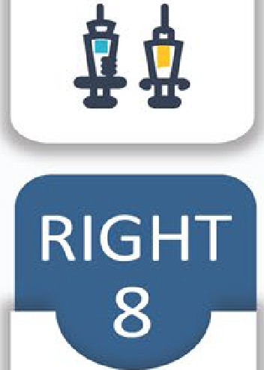

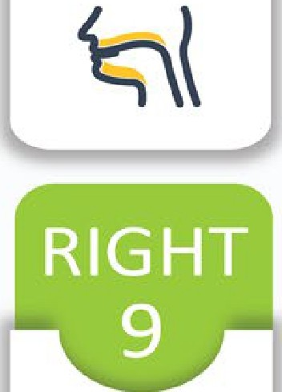





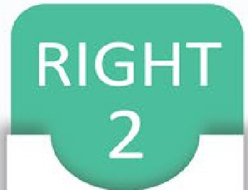







RIGHT DRUG
RIGHT ROUTE
RIGHT TIME
RIGHT RESPONSE
RIGHT
DOCUMENTATION

RIGHT ACTION
RIGHT REASON

RIGHT FORM
RIGHT PATIENT

RIGHT DOSE
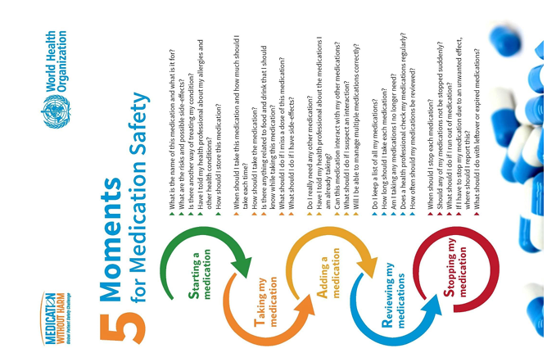
Mental Health Nursing Practice Placement 1
Medication | Medication | Dose/ Route | Frequency | Peak | Contraindications | Side- effects | Observed
Generic/Brand/Trade | Group and | Dose/ Route | Frequency | Action/ |  | Side- effects | administration
Name | Indications | Dose/ Route | Frequency | duration of | Cautions / Nursing | Side- effects | of medication
Choose medication |  | Dose/ Route | Frequency | action | Considerations | Side- effects
related to specific |  | Dose/ Route | Frequency | (If available) |  | Side- effects
clinical area |  | Dose/ Route | Frequency |  |  | Side- effects
1.
2.

3.

Student Signature: Registered Nurse/Preceptor’s Signature: Date:

Mental Health Nursing Practice Placement 2
Medication Generic Brand /Trade Name Choose medication related to a specific clinical area | Medication Group and Indications | Dose/ Route | Frequency | Peak Action / Duration of action (if available) | Contraindications / Cautions / Nursing Considerations | Side- effects | Observed administration of medication
1.
2.

3.

Student Signature: Registered Nurse/Preceptor’s Signature: Date:

Mental Health Practice Placement – Additional space

Medication Generic Brand /Trade Name Choose medication related to a specific clinical area | Medication Group and Indications | Dose/ Route | Frequency | Peak Action / Duration of action (if available) | Contraindications / Cautions / Nursing Considerations | Side- effects | Observed administration of medication
1.
2.

3.

Student Signature: Registered Nurse/Preceptor’s Signature: Date:

Suggested reading:
Berman, A. and Synder, S. (2012) Kozier & Erb's fundamentals of Nursing: Concepts, Process and Practice. 9th edn., New Jersey: Pearson Prentice Hall.
Brady, A., Malone, A. and Fleming, S. (2009) ‘A literature review of the individual and systems factors that contribute to medication errors in nursing practice’, Journal of Nursing Management, 17, pp.679- 697.
Dougherty, L., Lister, S., and West-Oram A. (eds) (2015) The Royal Marsden Hospital Manual of Clinical Nursing Procedures. 9th edn., Oxford: Wiley Blackwell Publishing.
Drach-Zahavy, A. and Pud, D. (2010) ‘Learning mechanisms to limit medication administration errors’, Journal of Advanced Nursing, 66(4), pp.794-805.

Gatford,D.J; Philips, N.(2016) Nursing Calculations, Elsevier, London

Health Information and Quality Authority (2015) Medicines Management Guidance. Dublin: Health Information and Quality Authority
Health Products Regulatory Authority (2014) Safety Information. Available online: http://www.hpra.ie/homepage/medicines/safety- information

Jones, S.W. (2009) ‘Reducing medication administration errors in nursing practice’, Nursing Standard, 23 (50), pp40-46. Nursing and Midwifery Board of Ireland (2015) Scope of Nursing and Midwifery Practice Framework. Dublin: NMBI.
Nursing and Midwifery Board of Ireland (2018) Standards for Registered Nurses and Midwives on Medication Administration [Draft]. Dublin: NMBI.

Reid-Searl, K., Moxham, L. and Happell, B. (2010) ‘Enhancing patient safety: The importance of direct supervision for avoiding medication errors and near miss by undergraduate nursing students’, International Journal of Nursing Practice, 16, pp.225-232.

Starkings, S & Krause, L. (2018) Passing Calculations Tests in Nursing, 3rd edn., London: SAGE Publication Ltd.

Useful websites
Nursing and Midwifery Board of Ireland (2018) Guidance to Nurses and Midwives on Medication Management. Available at: https://www.nmbi.ie/Standards-Guidance/Medicines-Management (Accessed 14 August 2018)

Drug calculations quiz page (page (2018) Available at :http://www.testandcalc.com/quiz/index.asp (Accessed 14 August 2018) Dosagehelp.com (2018) Available online at: http://www.dosagehelp.com/(Accessed: 30th August 2018)
Queens University Belfast, Numeracy Skills for Drug Calculations, Available at: https://www.qub.ac.uk/elearning/public/NumeracySkillsforDrugCalculations/(Accessed: 09th October, 2019)

Drug calculations quiz page (page (2018) Available at:http://www.testandcalc.com/quiz/index.asp (Accessed 14 August 2018)
World Health Organizations (2019) 5 Moments for medication safety, Available at: https://www.who.int/patientsafety/medication- safety/5moments/en/ (Accessed: 09th October, 2019)

19
CASC 2025
NCAD© UCD

